
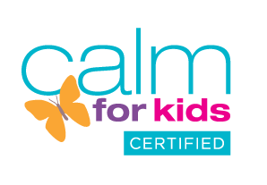

Yoga Nuts – Autumn 2026
We use a mixture of games and stories to make yoga fun. We focus on feeling good and learn techniques to deal with anxieties and worries. I am an experienced and fully qualified yoga teacher, who is DBS checked and safeguarding trained. For children in years R to 6. Sibling discounts available.
We need a minimum of six children to run the club, and numbers are capped at twelve.
Time: 3.15-4.15 every Thursday
Club dates: Thursday 11th September to Thursday 17th December. No club in half term.
Cost: £84 for the 14 week block.
What does my child need? Children can take part in school uniform, but may want to change into leggings or jogging bottoms so that they can move more easily.
How to book: Please complete this form and email it to me along with your payment. Payment is by PayPal to boxmooryoga@yahoo.co.uk or bank transfer to M Oliver, 308049, 32206968.
Child’s name:

Year:

Health issues:

Parent/carer email

I consent to Boxmoor Yoga emailing me about classes
Emergency contact telephone:

I look forward to welcoming your child to our club!
Maria Oliver BWY Dip
www.boxmooryoga.co.uk
boxmooryoga@yahoo.co.uk

